Set 2: Elective 2: Russia and the Soviet Union 1914–1945
Source 1
(Poster, produced in Russia between 1918 and 1922.)
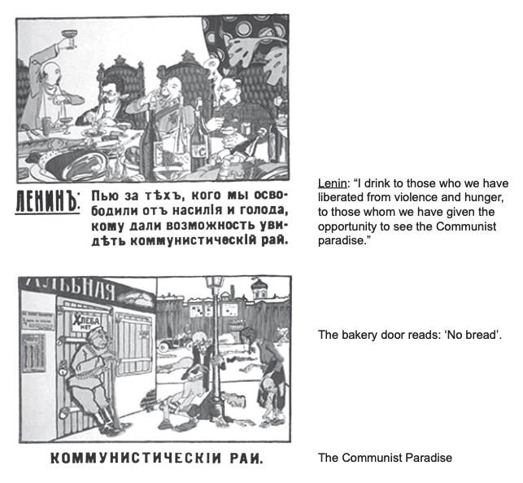

Source 2
(Extract from Vladimir Lenin’s speech to the Second All-Russia Congress of Soviets of Workers’ and Soldiers’ Deputies on 25 October, 1917 [Gregorian Calendar].)

“The Provisional Government has been overthrown. The majority of the members of the Provisional Government have already been arrested. The Soviet government will propose an immediate democratic peace to all the nations and an immediate armistice on all fronts. It will secure the transfer of the land … to the peasant committees without compensation; it will protect the rights of the soldiers by introducing complete democracy in the army; it will establish workers’ control over production; it will ensure the convocation1 of the Constituent Assembly at the time appointed; it will see to it that bread is supplied to the cities and prime necessities to the villages ...” 1 convocation – a large formal assembly or gathering

Source 3
(Cartoon by British cartoonist, Bernard Partridge published in Punch magazine, 28 January, 1920.)
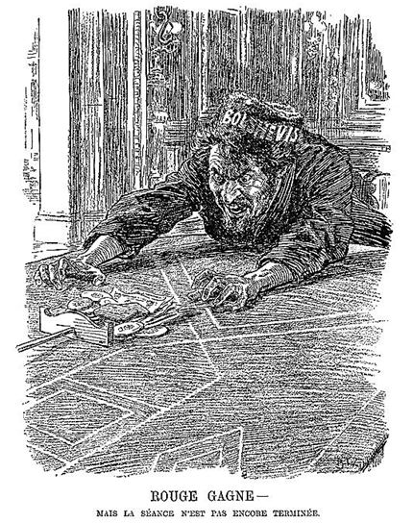

The cartoon reads: ‘RED WINS – but the game is not over yet.’

Source 4
(Extract from O. Figes, A People’s Tragedy: The Russian Revolution 1891–1924, published in New York in 1996.)

… whereas the élite of the tsarist regime was socially alien to the common people ... the Soviet élite was made up for the most part of ordinary Russians ... who spoke, dressed and acted much like everybody else. This gave the Soviet system a decisive advantage over the Whites in the civil war: it enabled it to hold on to the emotive symbols of ‘the Revolution’, the Red Flag above all else, and thus to present itself as the champion of the people’s cause. The ‘old regime’ image of the Whites, which was largely merited by their old regime mentality, and their obstinate refusal to endorse the peasant revolution on the land or to recognize the break-up of the Tsarist Empire, strengthened the Bolsheviks’ propaganda claim. The emphatic¹ rejection of the Whites by the peasantry and the non-Russians determined the outcome of the civil war.

¹ emphatic – express forcefully

Set 5: Elective 2: Australia’s engagement with Asia
Source 1
(Cartoon, depicting Asia’s reaction to the policies of the Australian Minister for Immigration, Arthur Calwell, first published in the Singapore Free Press around 1949.)

Source 2
(Extract from an announcement in the House of Representatives by Hubert Opperman, the Australian Minister for Immigration, on 9 March, 1966.)

“When in 1956 the Government reviewed the policy, which had been followed since Federation, of not admitting persons of non-European origin for permanent residence, it introduced several significant reforms. Those people already settled here became eligible to be naturalised ... and it was made possible for highly qualified people to come here for indefinite stay, though under temporary permits ... The government has now decided [that] ... non-European people who are already here under temporary permits ... should be able to apply [for resident status] after five years’ residence …

… the basic aim of preserving a homogenous¹ population will be maintained ... but the widening of eligibility will help to fill some of Australia’s special needs.”

¹ homogenous – of the same kind

Source 3
(Photograph of graffiti published in an Australian newspaper in the mid-1980s.)

Source 4
(Extract from an article by Andrew Jakubowicz, published in The Australian, on 9 May, 2002, entitled ‘Hot terms keep debate on the boil’.)

Multiculturalism refers to a policy developed in the ‘70s by Australian governments looking for a way of replacing assimilationist policies. It was based upon a belief that society would work better if people felt their cultural beliefs were respected and that they did not have to abandon their values to be considered good Australians ...

Many conservative groups believe multiculturalism should be abandoned and all programs that support it should be closed. On the other hand, most people recognise the reality of Australia as a multicultural society and are proud of the diversity of cultures and the overwhelming success of different ethnic communities getting on together with little conflict and a great deal of mutual benefit.

